[DATE]

[ADDRESS]

Action Required:
Register to Receive United American Insurance Company Payments as Free ERA/EFT

Dear Billing Manager,
United American Insurance Company has joined the InstaMed Network to deliver your payments via free electronic remittance advice (ERA) and electronic funds transfer (EFT). To receive United American Insurance Company payments as free ERA/EFT, register at www.instamed.com/eraeft.

ERA/EFT is a convenient, paperless and secure way to receive claim payments. Funds are deposited directly into your designated bank account and include the TRN Reassociation Trace Number, in accordance with CAQH CORE Phase III Operating Rules for HIPAA standard transactions. Additional benefits include:

- Accelerated access to funds with direct deposit into your existing bank account
- Reduced administrative costs by eliminating paper checks and remittances
- No disruption to your current workflow – there is an option to have ERAs routed to your existing clearinghouse

You have two simple options to register for free ERA/EFT from InstaMed:

- Register at www.instamed.com/eraeft

- Call us at (866) 945-7990 to speak with a live agent

Please do not hesitate to contact us directly at (866) 945-7990 or connect@instamed.com with any questions about this free solution.

Sincerely,
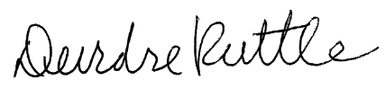

Chris Voth
Divisional Vice President
United American Insurance
Deirdre Ruttle
Chief Marketing Officer
InstaMed, a J.P. Morgan company

